Prezi

  - Introduce Prezi Creator: Adam Somlai-Fischer

  - Show sample Prezi

  - Sign in or create account- “Edu Enjoy” license free for educators
(Scroll to bottom- Product- Pricing-Student/Teacher Licenses)

  - Choose “blank” or pick a template ---- (Brainstorming)

  - Canvas
- in edit mode has a grid
- grid not visible in present mode

- Zoom Bar
-right side of the canvas
-affects the entire canvas
-zoom in/out
-home takes you back to the level you started
-clicking the Home button before you start making a prezi will also ensure that you're starting from the right place

  - Top Menu
- Left-hand side: present your prezi, create a new prezi in a new menu, save the prezi you are working on, undo your most recent action, or redo something that you just undid.
- Center : find all the tools you need to create prezi presentations.
- Right-hand side : these buttons give you access to prezi meeting, printing options, settings, and help, as well as the option to save and exit your current Prezi session.

- Templates-----Theme Wizard
-use the Theme Wizard to customize the colors of your prezi and to set your font choices from prezi's font library
-add a logo

- Transformation Bar
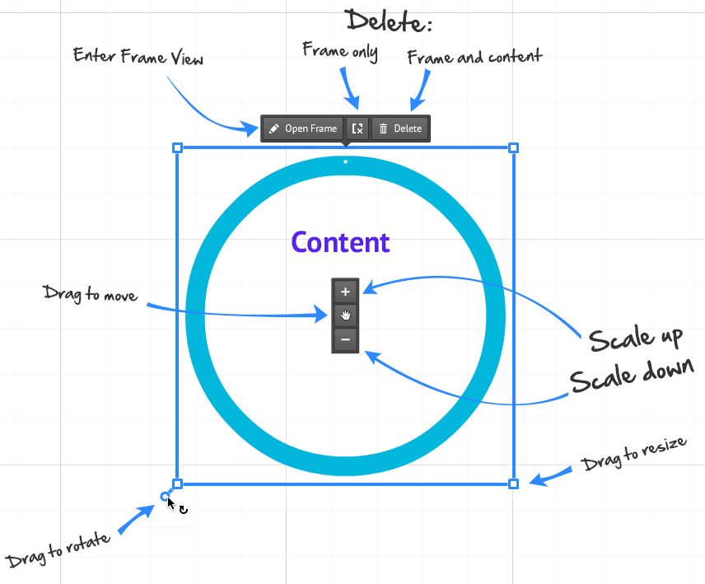
-appears with a single left click on a frame, object, image, or text
-double click allows you to edit your text
-grab on hand to drag around the canvas
-to rotate, navigate to the corners and rotate
-(+)/(-) to change size
-right click to bring up another menu with many options including layers

- Add Text
-left click on canvas
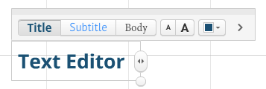

- Framing objects
-choose “Add Frames” from the top-center menu
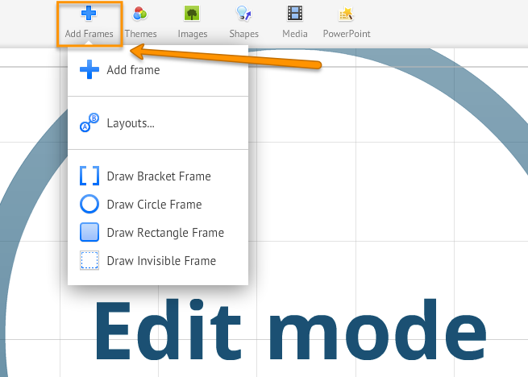
-from here you can select “Add frame” and Prezi will automatically place a frame onto your prezi canvas next to the content that you have been working on
-alternatively, you can select the kind of frame you would like to add from the list
-adding a frame will automatically add another step to your prezi’s path

- Draw shapes, arrows, and lines
-click the “Shapes” icon at the top of the screen to add shapes, lines, arrows, and more to your prezi
-insert rectangles, circles, and triangles to frame your content
-use arrows to show relationships between ideas
-highlight text with the highlighter
-jot down ideas and make sketches with the pencil

- Add URLS to your prezi
- to put live links into your prezi, copy and paste the desired URL into a text box. Then click away from the text box and your link will become active (you will see it automatically underline).
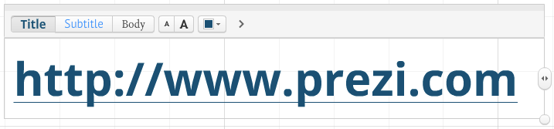

- Path points: navigate and rearrange with the Edit Path sidebar
-zoom out to see all objects on canvas
-click on objects in the order you wish to present them
-a thumbnail will be added to the left of your screen
-“x” button on thumbnail will remove a path point
-drag the midpoint circle between two already inserted path points to add an object between them
-drag the numbered circle to another object to change the order
-“Capture View” to add the current view to the end of your path
-“Delete All” will remove the whole path

- Present mode
-top left of the screen- blue
-to stop the path at any time click on an object to zoom in on it

-to resume the path use the arrows on the screen or on your keyboard
-fullscreen located on bottom right is an option that provides a clean-looking view

- Autoplay option
-hold down the timer button when in present mode and choose a timing interval
- interval choices: 4, 10, 20 seconds

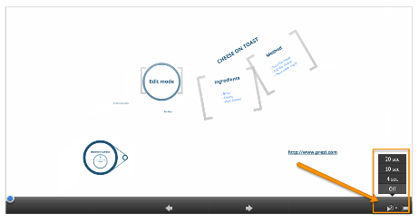

- Prezi meeting
-first select the prezi that you wish to work on with your friends or coworkers. ----click on the Prezi Meeting button in the top right-hand corner of the screen
-from here you will be presented with a drop down menu that will allow you to start presenting online (others will be able to view your prezi, but not edit it), invite others to edit your prezi online, or to share your prezi
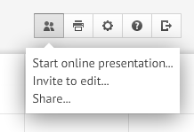
File Size Limitations: Maximum upload size is 50 MB per file

Image Size Limitations: Maximum size is 2880 X 2880 pixels
Supports JPG, PNG, GIF
Video File Formats: FLV,F4V, AVI, MOV, WMV, MPG, MPEG, MP4
M4V, 3GP

