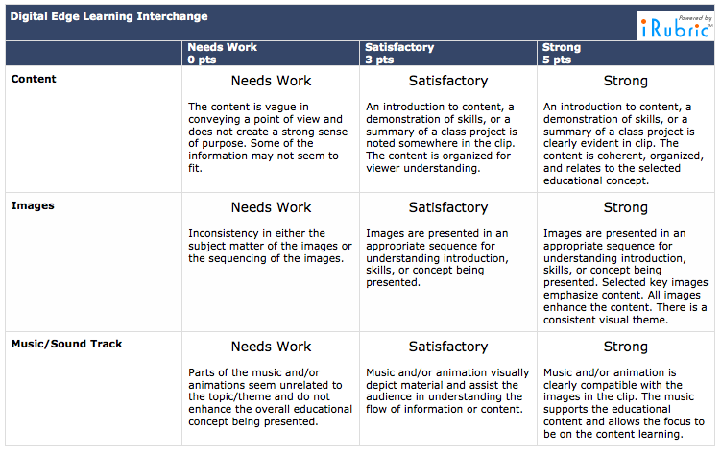

This rubric was found on the following website: www.rcampus.com/rubricshowc.cfm?code=KXC6B3&sp=yes

Animoto Rubric